Name:________________________________________
To Kill a Mockingbird Chapter 1 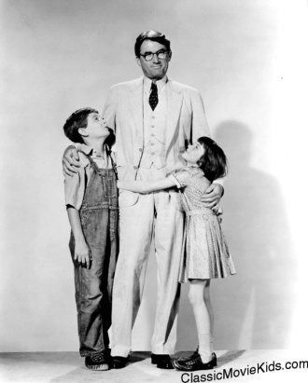
Before Reading:
- Read the quote by Charles Lamb before chapter 1. What does this mean? In your book, write: “Before Reading:” and jot down some thoughts about what you think this quote is referring to.
During Reading:
SUBSEARCH TASK: Note character descriptions and rumors about Boo Radley!
- If the narrator’s brother is four years her senior, and he was nearly 13 when he has his accident that broke his arm, how old is the narrator?

- What do you remember about yourself from this age?

- What is the narrator and Jem’s father’s name?

- The tradition in the Finch family is to stay at Finch’s landing and live off the land. What did the following Finches do?
- Atticus Finch:

- Jack(Atticus’s brother) Finch:

- Alexandra Finch:

- Atticus’s first two clients as a lawyer were the last two people hanged in Maycomb. Explain what they did.

- After reading through page 6, how would you describe Maycomb?

- The narrator describes the cook, Calpurnia on the bottom of page 6 and top of page 7. Does the narrators description of Calpurnia seem reliable? Why or why not?

- Why does Dill blush on page 9?

- List some of the rumors and oddities about Boo Radley and/or the Radley place (10/11).

- List what happened to Boo that caused him to be “not seen again for fifteen years” (Lee 13).

- On page 14, highlight what Atticus says about making people in to ghosts. What do you think this quote means?

- On page 16, mark the physical description of Boo Radley.
- Reread the excerpt about “making a turtle come out” at the bottom of page 17. What does this exchange tell you about our narrator?

After Reading:
- On page 19, react and or connect to something in chapter 1. What do you think about the kids? Do they remind you of anything? Does the creepy Radley house remind you of anything?

